EventHub – Event Seat Reservation System

Perfect 🔥
Now we finalize this like a proper system design.
Project Name (example):
EventHub – Event Seat Reservation System
You want:
- MongoDB
- Redis
- Worker Threads
- Streams
- Connection Pooling
- Clustering
- Clean but not huge
- Good React frontend
Let’s design it clearly.

🖥️ FRONTEND – Required Pages
🟢 Public Pages
1️⃣ Home Page
- Upcoming events
- Search + filter (category/date)
- Cached data
2️⃣ Event Details Page
- Event info
- Seat grid (1–100 seats)
- Seat status (available/booked)
- Book button

🟢 Authentication Pages
3️⃣ Login Page
4️⃣ Register Page

🟢 User Pages
5️⃣ My Bookings Page
- Booking history
- Pagination
- Filter by date
- Cancel booking (optional)
6️⃣ Booking Confirmation Page
- Ticket details
- Booking summary
7️⃣ Profile Page
- User info
- Change password (optional)

🔵 Admin Pages
8️⃣ Admin Dashboard
- Total events
- Total bookings
- Revenue stats (cached)
9️⃣ Create Event Page
- Title
- Date
- Location
- Total seats
- Price
10️⃣ Manage Events Page
- List of events
- Delete / view bookings
That’s 9–10 pages.
Perfect size.
Professional.

BACKEND

🟢 PUBLIC PAGES
1️⃣ Home Page
Backend:
- GET /events
- MongoDB Indexing (date, category)
- Connection Pooling

2️⃣ Event Details Page
Backend:
- GET /events/:id
- GET /events/:id/seats
- MongoDB Indexing (eventId, status)
- Connection Pooling

🟢 AUTH PAGES
3️⃣ Register Page
Backend:
- POST /auth/register
- Password Hashing
- MongoDB Insert
- Connection Pooling

4️⃣ Login Page
Backend:
- POST /auth/login
- JWT Generation
- MongoDB Query (indexed email)
- Connection Pooling

🟢 USER PAGES
5️⃣ Book Seat (from Event Details Page)
Backend:
- POST /bookings
- MongoDB Atomic Update (prevent double booking)
- Create Booking Record
- Worker Thread (ticket generation + email)
- Connection Pooling

6️⃣ Booking Confirmation Page
Backend:
- GET /bookings/:id
- Indexed Query (bookingId, userId)
- Connection Pooling

7️⃣ My Bookings Page
Backend:
- GET /bookings/my
- MongoDB Indexing (userId, createdAt)
- Pagination (limit + skip)
- Optional Redis Caching
- Connection Pooling

8️⃣ Cancel Booking (optional)
Backend:
- PATCH /bookings/:id/cancel
- Atomic Seat Release
- Cache Invalidation
- Worker Thread (refund logic optional)
- Connection Pooling

🔵 ADMIN PAGES
9️⃣ Admin Dashboard
Backend:
- GET /admin/dashboard
- MongoDB Aggregation
- Connection Pooling

🔟 Create Event Page
Backend:
- POST /admin/events
- Bulk Seat Generation
- Streams (bulk insert seats)
- MongoDB Indexing (eventId)
- Cache Invalidation
- Connection Pooling

1️⃣1️⃣ Manage Events Page
Backend:
- GET /admin/events
- Indexed Queries
- DELETE /admin/events/:id
- Cache Invalidation
- Connection Pooling

1️⃣2️⃣ Export Bookings (Admin)
Backend:
- GET /admin/export-bookings
- MongoDB Cursor Stream
- Node.js Streams (CSV generation)
- Connection Pooling

DB :
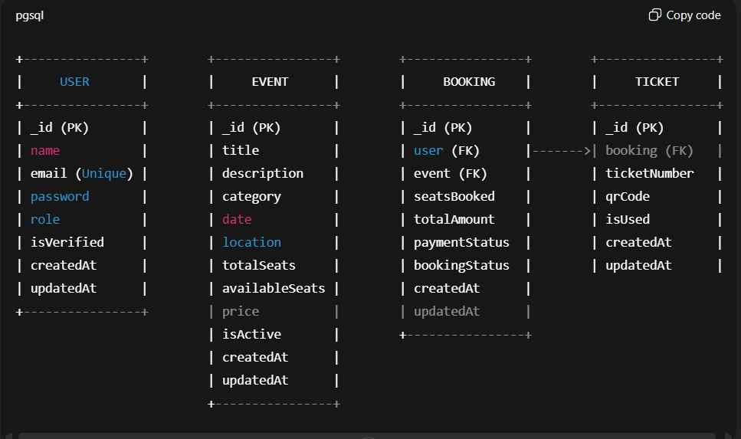

About Pool:

- Mongoose asks pool: "Give me a free connection"
- Pool gives one available connection
- Query runs
- Query finishes
- Connection goes back to pool
Connections are NOT assigned per user.
They are assigned per DATABASE OPERATION.
After query finishes:
→ Connection returns to pool
→ Ready for next request

